1. **Manipulating Data with dplyr**

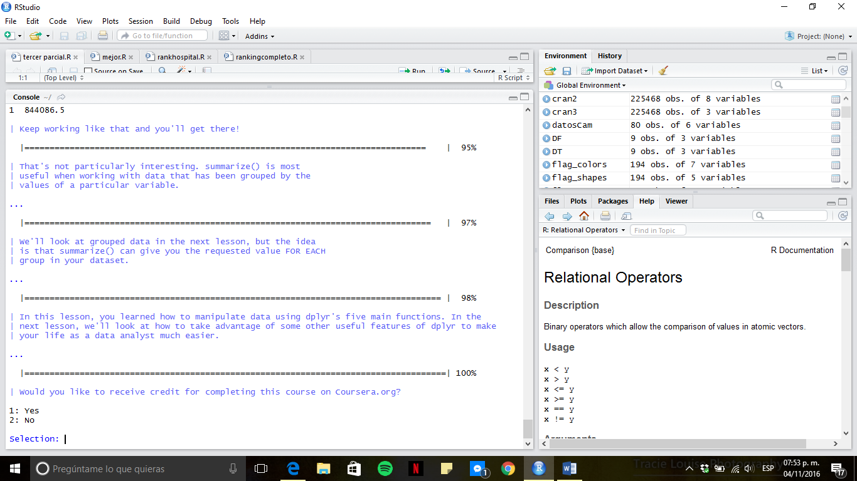

1. **Grouping and Chaining with dplyr**

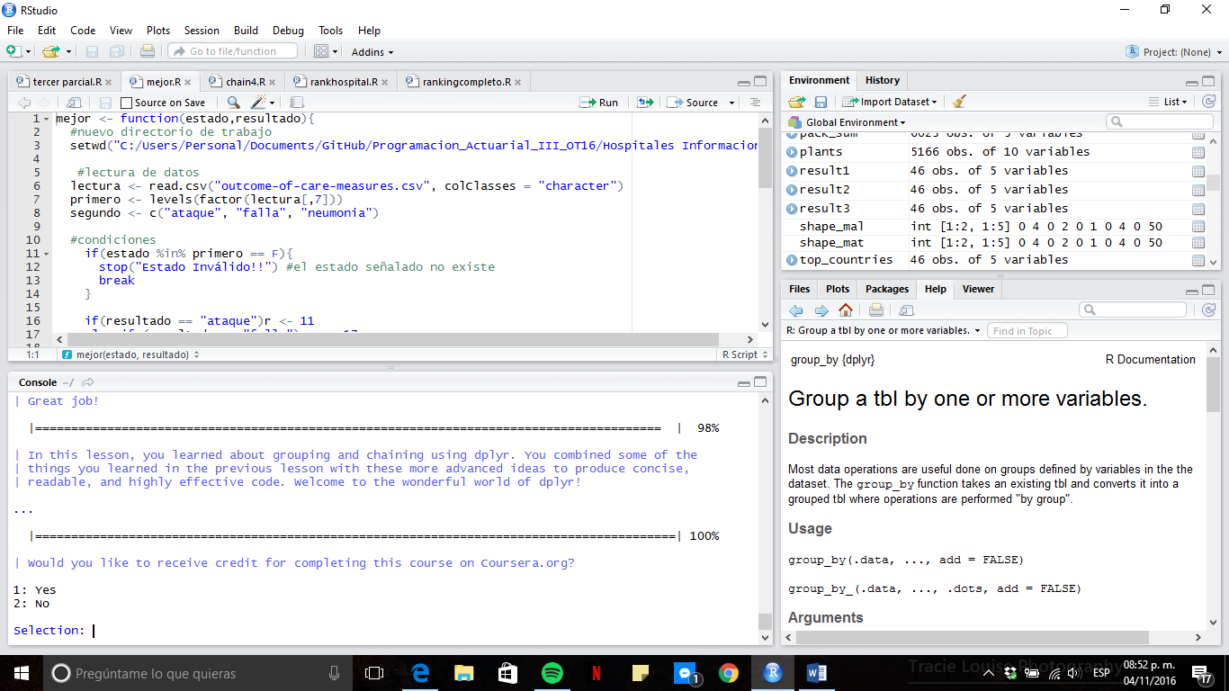

1. **Tidying Data with tidyr**

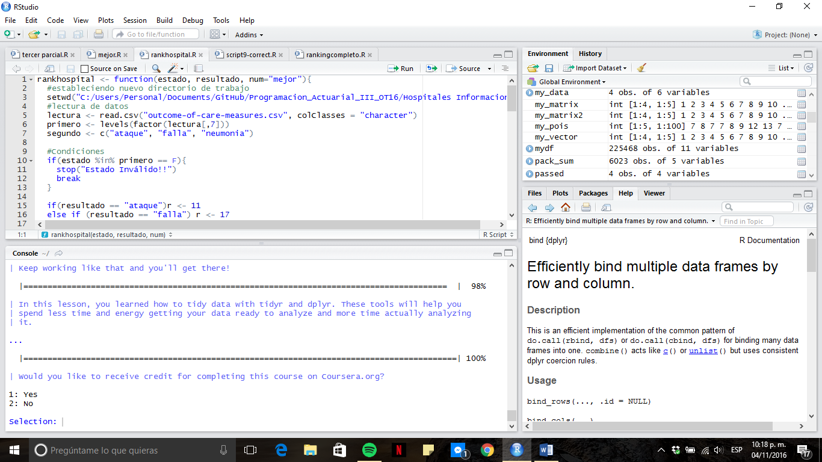

1. **Dates and Times with lubridate**

